Sana Khan

IST 659 Project

2/13/2022

Part One

Business Plan:

Why settle for boring coffee that doesn’t even taste good, when you can get a coffee of your choice delivered right to your door? With a membership to Coco’s Coffee Club you’ll have the opportunity to try unique coffees from all over the world. We partner with roasters who carefully curate their selection by working with independent farmers to bring a wide variety of options to choose from. You can then customize your subscription by letting us know your preferences so we can match you to what you like. Or you can be bold and let us send you something new to try! Either way, your days are going to start off a lot better than before.

Stakeholders:

* Roasters – those who are sourcing and roasting coffees to send to our customers
* Customers – those who have an active subscription

Business Rules:

* There are two tiers that a customer can select for as part of their membership, standard or deluxe. A standard subscription is $14.99 and a deluxe subscription is $19.99. A deluxe subscription unlocks access to more single origin and lighter roast coffees
* Customers can pick the frequency to be once a week, bi-weekly, or monthly
* Subscriptions will auto renew
* There is a flat rate $5 shipping. This is subject to change
* Customers must use a credit card for payment
* Customers can cancel or pause their membership

Data Questions:

* How many active subscriptions do we have at a point in time?
* Where are our roasters located?
* What are our most popular coffees?
* How many customers canceled their membership
* What cities do our customers live in?

Conceptual Model:

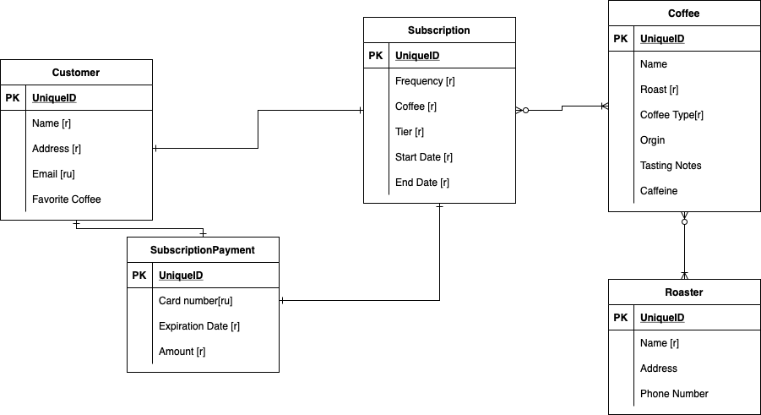

Logical Model:

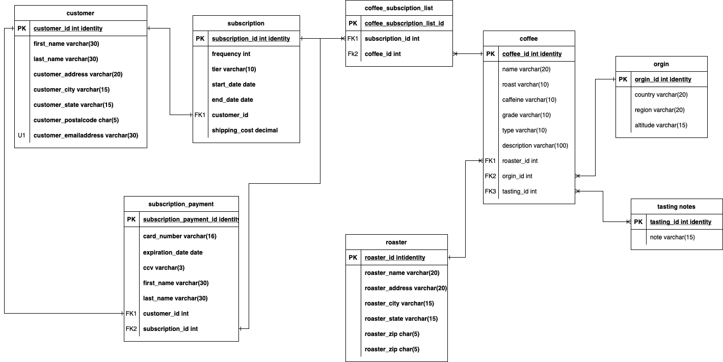

PART II

Insert Statements:

DROP TABLE IF EXISTS tasting_notes

DROP TABLE IF EXISTS orgin

DROP TABLE IF EXISTS roaster

DROP TABLE IF EXISTS coffee

DROP TABLE IF EXISTS customer

DROP TABLE IF EXISTS subscription

DROP TABLE IF EXISTS coffee_subsciption_list

DROP TABLE IF EXISTS subscription_payment

CREATE TABLE tasting_notes(

--Columns for tasting_notes table --

tasting_id int identity

,note varchar(15) not null

CONSTRAINT PK_tasting_notes PRIMARY KEY (tasting_id)

)

CREATE TABLE orgin (

--Columns for the orgin table --

 orgin_id int identity

 ,country varchar(20) not null

,region varchar(20) not null

,altitude varchar(15)

CONSTRAINT PK_orgin PRIMARY KEY (orgin_id)

)

DROP TABLE IF exists roaster

CREATE TABLE roaster (

--Columns for the roaster table --

 roaster_id int identity

 ,roaster_name varchar(20) not null

,address varchar(20) not null

,city varchar(15) not null

,state varchar(15) not null

,zipcode char(15) not null

,phone_number varchar(10) not null

CONSTRAINT PK_roaster PRIMARY KEY (roaster_id)

)

CREATE TABLE coffee (

--Columns for the coffee table -

 coffee_id int identity

 ,name varchar(20) not null

,roast varchar(10) not null

,caffeine varchar(10) not null

,grade varchar(10) not null

,type char(10) not null

,description varchar(100) not null

,roaster_id int not null

,orgin_id int not null

,tasting_id int not null

CONSTRAINT PK_coffee PRIMARY KEY (coffee_id)

,CONSTRAINT FK1_coffee FOREIGN KEY (roaster_id) REFERENCES roaster(roaster_id)

,CONSTRAINT FK2_coffee FOREIGN KEY (orgin_id) REFERENCES orgin(orgin_id)

,CONSTRAINT FK3_coffee FOREIGN KEY (tasting_id) REFERENCES tasting_notes(tasting_id)

)

CREATE TABLE customer (

--Columns for the customer table --

 customer_id int identity

 ,first_name varchar(30) not null

 ,last_name varchar(30) not null

,customer_address varchar(20) not null

,customer_city varchar(15) not null

,customer_state varchar(15) not null

,customer_zipcode char(15) not null

,customer_email_address varchar(30) not null

CONSTRAINT PK_customer PRIMARY KEY (customer_id)

,CONSTRAINT U1_customer UNIQUE (customer_email_address)

)

CREATE TABLE subsciption(

--Columns for the subscription table --

subsciption_id int identity

,frequency int not null

,tier varchar(10) not null

,start_date datetime not null

,end_date datetime not null

,shipping_cost decimal

,customer_id  int not null

CONSTRAINT PK_subscription PRIMARY KEY (subsciption_id)

,CONSTRAINT FK1_subscription FOREIGN KEY (customer_id) REFERENCES customer(customer_id)

)

CREATE TABLE coffee_subsciption_list(

--Columns for the coffee_subsciption_list table --

coffee_subsciption_list_id int identity

,subsciption_id int not null

,coffee_id int not null

CONSTRAINT PK_coffee_subsciption_list PRIMARY KEY (coffee_subsciption_list_id)

,CONSTRAINT FK1_coffee_subsciption_list FOREIGN KEY (subsciption_id) REFERENCES subsciption(subsciption_id )

,CONSTRAINT FK2_coffee_subsciption_list FOREIGN KEY (coffee_id) REFERENCES coffee(coffee_id)

)

CREATE TABLE subscription_payment(

--Columns for the subscription_payment table --

subscription_payment_id int identity

,card_number varchar(16) not null

,expiration_date datetime not null

,ccv varchar(3) not null

,first_name varchar(30)

,last_name varchar(30)

,customer_id int

,subscription_id int

CONSTRAINT PK_subscription_payment PRIMARY KEY (subscription_payment_id)

,CONSTRAINT FK1_subscription_payment FOREIGN KEY (customer_id) REFERENCES customer(customer_id )

,CONSTRAINT FK2_subscription_payment FOREIGN KEY (subscription_id) REFERENCES  subsciption(subsciption_id)

)

INSERT STATEMENTS

INSERT INTO roaster (roaster_name, address, city, state, zipcode, phone_number)

VALUES ('Asado', '568 Brentwood Way', 'Memphis','Tennessee','38181','9015179939')

INSERT INTO roaster (roaster_name, address, city, state, zipcode, phone_number)

VALUES('Dark Matter Coffee', '2 Warner Alley', 'Montgomery', 'Alabama', '36195','3348938485')

INSERT INTO roaster (roaster_name, address, city, state, zipcode, phone_number)

VALUES('Buzz Killer Espresso', '1 Homewood Trail', 'Tampa', 'Florida', '33686', '8133317297')

INSERT INTO roaster (roaster_name, address, city, state, zipcode, phone_number)

VALUES('Coffee Ambassadors', '7075 Iowa Parkway', 'Aurora', 'Illinois', '60505', '3314619483')

INSERT INTO roaster (roaster_name, address, city, state, zipcode, phone_number)

VALUES('Demitas', '905 Kedzie Way', 'Raleigh', 'North Carolina', '27635', '9148678678')

INSERT INTO roaster (roaster_name, address, city, state, zipcode, phone_number)

VALUES('cafe La Fortuna', '2 Prairieview Lane', 'Huntington', 'West Virginia', '25709', '3048266578')

INSERT INTO roaster (roaster_name, address, city, state, zipcode, phone_number)

VALUES('Kickapoo', '5 Sutherland Crossing', 'Wilmington', 'Delaware', '19805', '3026936090')

INSERT INTO roaster (roaster_name, address, city, state, zipcode, phone_number)

VALUES('Just Coffee', '7400 Di Loreto Center', 'Albuquerque', 'New Mexico', '87201', '5055048803')

VALUES('Red House Roasters', '8769 City Terrace', 'West Palm Beach', 'Florida', '33416', '5615343759')

INSERT INTO roaster (roaster_name, address, city, state, zipcode, phone_number)

VALUES('Rockn Joes', '31 Petterle Avenue', 'Pittsburgh', 'Pennsylvania', '15266', '4569894167')

INSERT INTO roaster (roaster_name, address, city, state, zipcode, phone_number)

VALUES('Ceremony', '6584 Loreto Place', 'Atlanta', 'Georgia', '30351', '4044501379')

INSERT INTO roaster (roaster_name, address, city, state, zipcode, phone_number)

VALUES('Rival Bros', '32 Sunbrook Road', 'Torrance', 'California', '90505', '3101888019')

INSERT INTO roaster (roaster_name, address, city, state, zipcode, phone_number)

VALUES('Green Street', '16 Gordon Court', 'Ann Arbor', 'Michigan', '48107', '7347408559')

INSERT INTO roaster (roaster_name, address, city, state, zipcode, phone_number)

VALUES('ReAnimator Coffee', '997 Cherokee Circle', 'Honolulu', 'Hawaii', '96835', '8082062102')

INSERT INTO roaster (roaster_name, address, city, state, zipcode, phone_number)

VALUES('One Village Coffee', '242 Grim Plaza', 'Dallas', 'Texas', '75358', '2142707824')

INSERT INTO roaster (roaster_name, address, city, state, zipcode, phone_number)

VALUES('la colombe', '34678 Hollow  Lane', 'Birmingham', 'Alabama', '35295', '2056651089')

INSERT INTO roaster (roaster_name, address, city, state, zipcode, phone_number)

VALUES('Gryphon', '5 Longview Crossing', 'Houston', 'Texas', '77030', '28141 8379')

INSERT INTO roaster (roaster_name, address, city, state, zipcode, phone_number)

VALUES('Erie Island Coffee', '02 Ohio Parkway', 'Los Angeles', 'California', '90076', '3239098266')

INSERT INTO roaster (roaster_name, address, city, state, zipcode, phone_number)

VALUES('Phoenix Coffee', '28 Spenser Court', 'Raleigh', 'North Carolina', '27635', '9196370050')

INSERT INTO roaster (roaster_name, address, city, state, zipcode, phone_number)

VALUES('Allegheny Coffee', '80294 Thierer Lane', 'Metairie', 'Louisiana', '70033', '5045120682')

INSERT INTO roaster (roaster_name, address, city, state, zipcode, phone_number)

INSERT INTO tasting_notes

VALUES

('Chocolate')

,('Hazelnut')

,('Citrus')

,('Floral')

,('Fruity')

,('Honey')

,('Brown Sugar')

,('Vanilla')

,('Nutty')

INSERT INTO orgin (Country, Region, Altitude)

VALUES ('Brazil', 'South America', '1200 - 1300 ')

INSERT INTO orgin (Country, Region, Altitude)

VALUES ('Brazil', 'South America', '1200 - 1300 ')

INSERT INTO orgin (Country, Region, Altitude)

VALUES ('Burundi', 'East Africa', '1700 - 1800')

INSERT INTO orgin (Country, Region, Altitude)

VALUES ('Ethiopia', 'East Africa', '1950 - 2000')

INSERT INTO orgin (Country, Region, Altitude)

VALUES ('Honduras', 'Central America ', '1350 - 1400')

INSERT INTO orgin (Country, Region, Altitude)

VALUES ('Indonesia', 'Southeast Asia', '1200 - 1800 ')

INSERT INTO orgin (Country, Region, Altitude)

VALUES ('Thailand', 'Southeast Asia', '1400 - 1500 ')

INSERT INTO orgin (Country, Region, Altitude)

VALUES ('Guatemala', 'Central America ', '5600 - 5760 ')

INSERT INTO orgin (Country, Region, Altitude)

VALUES ('Uganda', 'East Africa', '1600 - 1800')

INSERT INTO orgin (Country, Region, Altitude)

VALUES ('Peru', 'South America', '1300 - 1500')

INSERT INTO orgin (Country, Region, Altitude)

VALUES ('Costa Rica', 'Central America ', '1950 - 2250')

INSERT INTO orgin (Country, Region, Altitude)

VALUES ('Nicaragua', 'Central America ', '1300 - 1800')

INSERT INTO orgin (Country, Region, Altitude)

VALUES ('Kenya', 'East Africa', '1800 - 2000')

INSERT INTO orgin (Country, Region, Altitude)

VALUES ('Colombia', 'South America', '1300 - 1500')

INSERT INTO orgin (Country, Region, Altitude)

VALUES ('El Salvador', 'El Salvador', '900-1500m')

INSERT INTO customer (first_name ,last_name, customer_email_address,customer_address ,customer_city  ,customer_state  ,customer_zipcode)

VALUES ('Ulberto', 'Goodhand', 'ugoodhand0@sciencedaily.com', '551 Portage Point', 'Baltimore', 'Maryland', '21282')

INSERT INTO customer (first_name ,last_name, customer_email_address,customer_address ,customer_city  ,customer_state  ,customer_zipcode)

VALUES ('Shawna', 'Partleton', 'spartleton1@theatlantic.com', '2833 Towne Street', 'Garland', 'Texas', '75049')

INSERT INTO customer (first_name ,last_name, customer_email_address,customer_address ,customer_city  ,customer_state  ,customer_zipcode)

VALUES ('Casey', 'Harden', 'charden2@redcross.org', '658 Park Hill', 'Staten Island', 'New York', '10310')

INSERT INTO customer (first_name ,last_name, customer_email_address,customer_address ,customer_city  ,customer_state  ,customer_zipcode)

VALUES ('Eleanore', 'Brammall', 'ebrammall3@yahoo.co.jp', '6 Mcbride Plaza', 'Albany', 'New York', '12237')

INSERT INTO customer (first_name ,last_name, customer_email_address,customer_address ,customer_city  ,customer_state  ,customer_zipcode)

VALUES ('Caleb', 'Butterwick', 'cbutterwick4@over-blog.com', '0864 Aberg Crossing', 'Chicago', 'Illinois', '60604')

INSERT INTO customer (first_name ,last_name, customer_email_address,customer_address ,customer_city  ,customer_state  ,customer_zipcode)

VALUES ('Yvor', 'Dillinton', 'ydillinton5@bloglovin.com', '89544 Mitchell Alley', 'Baltimore', 'Maryland', '21290')

INSERT INTO customer (first_name ,last_name, customer_email_address,customer_address ,customer_city  ,customer_state  ,customer_zipcode)

VALUES ('Rhetta', 'Danigel', 'rdanigel6@1und1.de', '1 Mandrake Alley', 'Detroit', 'Michigan', '48206')

VALUES ('Leesa', 'Grahlman', 'lgrahlmanh@goo.ne.jp', '392 Memorial Crossing', 'Los Angeles', 'California', '90065')

INSERT INTO customer (first_name ,last_name, customer_email_address,customer_address ,customer_city  ,customer_state  ,customer_zipcode)

VALUES ('Jenna', 'Heselwood', 'jheselwoodi@cafepress.com', '293 Rieder Drive', 'Providence', 'Rhode Island', '2905')

INSERT INTO customer (first_name ,last_name, customer_email_address,customer_address ,customer_city  ,customer_state  ,customer_zipcode)

VALUES ('Jasper', 'Colin', 'jcolinj@chicagotribune.com', '79 Coolidge Court', 'Lexington', 'Kentucky', '40586')

INSERT INTO customer (first_name ,last_name, customer_email_address,customer_address ,customer_city  ,customer_state  ,customer_zipcode)

VALUES ('Wilek', 'Helliker', 'whellikerk@skyrock.com', '1943 Mcbride Lane', 'San Antonio', 'Texas', '78285')

VALUES ('Devonne', 'St Clair', 'dstclair4w@jimdo.com', '6 Jay Trail', 'West Palm Beach', 'Florida', '33421')

INSERT INTO subsciption(customer_id , start_date, end_date, tier ,frequency, shipping_cost)

VALUES ('1', '10/22/2019','1/1/9999', 'Standard', '1', '9.99')

INSERT INTO subsciption(customer_id , start_date, end_date, tier ,frequency, shipping_cost)

VALUES ('2', '12/12/2020', '1/1/9999', 'Deluxe', '1', '5.99')

INSERT INTO subsciption(customer_id , start_date, end_date, tier ,frequency, shipping_cost)

VALUES ('4', '3/8/2021', '1/1/9999', 'Standard', '3', '9.99')

INSERT INTO subsciption(customer_id , start_date, end_date, tier ,frequency, shipping_cost)

VALUES ('5', '4/10/2019', '2/23/2020', 'Deluxe', '4', '5.99')

INSERT INTO subsciption(customer_id , start_date, end_date, tier ,frequency, shipping_cost)

VALUES ('6', '7/26/2021', '1/1/9999', 'Standard', '3', '9.99')

INSERT INTO subsciption(customer_id , start_date, end_date, tier ,frequency, shipping_cost)

VALUES ('7', '11/15/2021', '1/1/999', 'Standard', '4', '9.99')

INSERT INTO subsciption(customer_id , start_date, end_date, tier ,frequency, shipping_cost)

VALUES ('8', '5/26/2019', '1/1/9999', 'Deluxe', '3', '5.99')

INSERT INTO subsciption(customer_id , start_date, end_date, tier ,frequency, shipping_cost)

VALUES ('9', '9/26/2020', '1/1/9999', 'Standard', '1', '9.99')

INSERT INTO subsciption(customer_id , start_date, end_date, tier ,frequency, shipping_cost)

VALUES ('10', '3/22/2019', '1/1/9999', 'Deluxe', '4', '5.99')

INSERT INTO subsciption(customer_id , start_date, end_date, tier ,frequency, shipping_cost)

VALUES ('11', '12/23/2019', '5/27/2019', 'Deluxe', '3', '5.99')

insert into coffee( name, roast, caffeine, grade,type, description, roaster_id, orgin_id, tasting_id)

Values ('Tweed ', 'Light', 'Caffeine', 'A', 'Single', 'arcu ac tortor dignissim convallis aenean et tortor at risus viverra a', '1', '4', '10')

insert into coffee( name, roast, caffeine, grade,type, description, roaster_id, orgin_id, tasting_id)

Values ('Pink Lady Blend', 'Medium', 'Caffeine', 'A', 'Blend', 'eros viverra eget congue eget semper rutrum nulla nunc purus phasellus in ', '2', '9', '10')

insert into coffee( name, roast, caffeine, grade,type, description, roaster_id, orgin_id, tasting_id)

Values ('Intelligentsia', 'Dark', 'Caffeine', 'B', 'Espresso', 'interdum venenatis turpis enim blandit mi in porttitor pede justo eu massa donec dapibus', '3', '1', '6')

insert into coffee( name, roast, caffeine, grade,type, description, roaster_id, orgin_id, tasting_id)

Values ('Stumptown', 'Light', 'Caffeine', 'B', 'Blend', 'amet turpis elementum ligula vehicula consequat morbi a ipsum integer a nibh in quis', '4', '7', '5')

insert into coffee( name, roast, caffeine, grade,type, description, roaster_id, orgin_id, tasting_id)

Values ('Founders', 'Light', 'Caffeine', 'B', 'Single', 'integer tincidunt ante vel ipsum praesent blandit lacinia erat vestibulum', '5', '9', '4')

insert into coffee( name, roast, caffeine, grade,type, description, roaster_id, orgin_id, tasting_id)

Values ('Producers Pride', 'Light', 'Caffeine', 'A', 'Espresso', 'in lectus pellentesque at nulla suspendisse potenti cras in purus', '6', '6', '16')

insert into coffee( name, roast, caffeine, grade,type, description, roaster_id, orgin_id, tasting_id)

Values ('Zamit', 'Dark', 'Decaf ', 'B', 'Blend', 'quisque ut erat curabitur gravida nisi at nibh in hac pellentesque at nulla que penatibus et magnis', '7', '15', '11')

insert into coffee( name, roast, caffeine, grade,type, description, roaster_id, orgin_id, tasting_id)

Values ('Voltsillam', 'Medium', 'Caffeine', 'A', 'Espresso', 'vivamus vestibulum sagittis sapien cum sociis natoque penatibus et magnis dis parturient', '10', '11', '14')

insert into coffee( name, roast, caffeine, grade,type, description, roaster_id, orgin_id, tasting_id)

Values ('Lotstring', 'Medium', 'Caffeine', 'A', 'Single', 'pede lobortis ligula sit amet eleifend pede libero quis orci nullam molestie nibh in lectus ', '11', '9', '17')

insert into coffee( name, roast, caffeine, grade,type, description, roaster_id, orgin_id, tasting_id)

Values ('Zoolab', 'Dark', 'Caffeine', 'B', 'Blend', 'amet sapien dignissim vestibulum vestibulum ante ipsum primis in faucibus orci luctus et ultrices', '12', '3', '8')

insert into coffee( name, roast, caffeine, grade,type, description, roaster_id, orgin_id, tasting_id)

Values ('Pannier', 'Medium', 'Decaf', 'A', 'Espresso', 'nunc nisl duis bibendum felis sed interdum venenatis turpis enim blandit mi in porttitor', '14', '9', '3')

insert into coffee( name, roast, caffeine, grade,type, description, roaster_id, orgin_id, tasting_id)

Values ('Headwall', 'Light', 'Caffeine', 'A', 'Espresso', 'faucibus cursus urna ut tellus nulla ut erat id mauris vulputate elementum nullam', '15', '4', '9')

insert into coffee( name, roast, caffeine, grade,type, description, roaster_id, orgin_id, tasting_id)

Values ('Stim', 'Dark', 'Caffeine', 'A', 'Single', 'non velit nec nisi vulputate nonummy maecenas tincidunt lacus at velit vivamus vel nulla eget', '62', '16', '8')

insert into coffee( name, roast, caffeine, grade,type, description, roaster_id, orgin_id, tasting_id)

Values ('Flowdesk', 'Light', 'Decaf', 'A', 'Blend', 'dapibus augue vel accumsan tellus nisi eu orci mauris lacinia sapien quis libero', '64', '17', '11')

insert into coffee( name, roast, caffeine, grade,type, description, roaster_id, orgin_id, tasting_id)

Values ('Alpha', 'Dark', 'Decaf', 'A', 'Espresso', 'curabitur gravida nisi at nibh in hac habitasse platea dictumst aliquam augue', '65', '4', '13')

insert into coffee( name, roast, caffeine, grade,type, description, roaster_id, orgin_id, tasting_id)

Values ('Wrapsafe', 'Medium', 'Caffeine', 'A', 'Single', 'venenatis turpis enim blandit mi in porttitor pede justo eu massa', '69', '9', '15')

INSERT INTO subscription_payment(card_number, expiration_date, ccv, first_name, last_name, customer_id, subscription_id)

VALUES ('372301374183319', '2/10/22', '446', 'Ulberto', 'Goodhand', 1, 1)

INSERT INTO subscription_payment(card_number, expiration_date, ccv, first_name, last_name, customer_id, subscription_id)

VALUES ('5038122306943470', '9/5/22', '448', 'Casey', 'Harden', 4, 4)

INSERT INTO subscription_payment(card_number, expiration_date, ccv, first_name, last_name, customer_id, subscription_id)

VALUES ('5602257988987180', '9/21/21', '444', 'Eleanore', 'Brammall', 5, 5)

INSERT INTO subscription_payment(card_number, expiration_date, ccv, first_name, last_name, customer_id, subscription_id)

VALUES ('36568811857394', '11/18/21', '445', 'Caleb', 'Butterwick', 6, 6)

INSERT INTO subscription_payment(card_number, expiration_date, ccv, first_name, last_name, customer_id, subscription_id)

VALUES ('3567332387538150', '9/27/22', '448', 'Yvor', 'Dillinton', 7, 7)

INSERT INTO subscription_payment(card_number, expiration_date, ccv, first_name, last_name, customer_id, subscription_id)

VALUES ('5602258891672150', '5/14/23', '450', 'Corilla', 'Maundrell', 9, 9)

INSERT INTO subscription_payment(card_number, expiration_date, ccv, first_name, last_name, customer_id, subscription_id)

VALUES ('3559600663192560', '6/12/22', '447', 'Godiva', 'Howse', 10, 10)

INSERT INTO subscription_payment(card_number, expiration_date, ccv, first_name, last_name, customer_id, subscription_id)

VALUES ('201768632738232', '6/4/21', '443', 'Ina', 'Blackmuir', 11, 11)

INSERT INTO subscription_payment(card_number, expiration_date, ccv, first_name, last_name, customer_id, subscription_id)

VALUES ('6381842826712090', '8/24/21', '444', 'Ulysses', 'Moiser', 12, 12)

INSERT INTO subscription_payment(card_number, expiration_date, ccv, first_name, last_name, customer_id, subscription_id)

VALUES ('3566269985872460', '2/15/23', '449', 'Creight', 'Doole', 13, 13)

INSERT INTO subscription_payment(card_number, expiration_date, ccv, first_name, last_name, customer_id, subscription_id)

VALUES ('5893290258757090', '5/15/22', '446', 'Gusty', 'Huyton', 14, 14)

INSERT INTO subscription_payment(card_number, expiration_date, ccv, first_name, last_name, customer_id, subscription_id)

VALUES ('30045795159614', '2/4/22', '445', 'Mort', 'Bailey', 15, 15)

INSERT INTO subscription_payment(card_number, expiration_date, ccv, first_name, last_name, customer_id, subscription_id)

VALUES ('3539447253079140', '11/13/21', '445', 'Amie', 'Thickins', 16, 16)

INSERT INTO subscription_payment(card_number, expiration_date, ccv, first_name, last_name, customer_id, subscription_id)

VALUES ('374622872581201', '7/6/22', '447', 'Darrelle', 'Faustian', 17, 17)

INSERT INTO coffee_subsciption_list(subsciption_id, coffee_id)

VALUES (1, 10)

INSERT INTO coffee_subsciption_list(subsciption_id, coffee_id)

VALUES (4, 46)

INSERT INTO coffee_subsciption_list(subsciption_id, coffee_id)

VALUES (5, 10)

INSERT INTO coffee_subsciption_list(subsciption_id, coffee_id)

VALUES (6, 11)

INSERT INTO coffee_subsciption_list(subsciption_id, coffee_id)

VALUES (7, 43)

INSERT INTO coffee_subsciption_list(subsciption_id, coffee_id)

VALUES (9, 39)

INSERT INTO coffee_subsciption_list(subsciption_id, coffee_id)

VALUES (10, 13)

INSERT INTO coffee_subsciption_list(subsciption_id, coffee_id)

VALUES (11, 46)

INSERT INTO coffee_subsciption_list(subsciption_id, coffee_id)

VALUES (12, 31)

INSERT INTO coffee_subsciption_list(subsciption_id, coffee_id)

VALUES (13, 7)

INSERT INTO coffee_subsciption_list(subsciption_id, coffee_id)

VALUES (14, 38)

INSERT INTO coffee_subsciption_list(subsciption_id, coffee_id)

VALUES (15, 38)

INSERT INTO coffee_subsciption_list(subsciption_id, coffee_id)

VALUES (16, 10)

INSERT INTO coffee_subsciption_list(subsciption_id, coffee_id)

VALUES (17, 8)

INSERT INTO coffee_subsciption_list(subsciption_id, coffee_id)

VALUES (18, 17)

INSERT INTO coffee_subsciption_list(subsciption_id, coffee_id)

VALUES (21, 42)

INSERT INTO coffee_subsciption_list(subsciption_id, coffee_id)

VALUES (22, 39)

INSERT INTO coffee_subsciption_list(subsciption_id, coffee_id)

VALUES (23, 23)

INSERT INTO coffee_subsciption_list(subsciption_id, coffee_id)

VALUES (24, 34)

INSERT INTO coffee_subsciption_list(subsciption_id, coffee_id)

VALUES (25, 27)

INSERT INTO coffee_subsciption_list(subsciption_id, coffee_id)

VALUES (26, 34)

INSERT INTO coffee_subsciption_list(subsciption_id, coffee_id)

VALUES (27, 3)

Answering Data Questions:

How many active customers are there:

SELECT COUNT(subsciption_id) as Number_Active_Customers

FROM dbo.subsciption

WHERE end_date = '9999-01-01'

Where are our roasters located?

CREATE VIEW roaster_location AS

SELECT count(roaster_id) AS number_roasters

,city

FROM roaster

GROUP BY city

GO

SELECT * FROM roaster_location

ORDER BY number_roasters DESC

What are our most popular coffees?

CREATE VIEW Coffee_List AS

SELECT s.*

,c.*

FROM subsciption s

left join coffee_subsciption_list cs on s.subsciption_id = cs.subsciption_id

left join coffee c on c.coffee_id = cs.coffee_id

GO

SELECT c.name,

COUNT( cl.coffee_id) as Coffee_Count

from Coffee_List cl

left join coffee c on c.coffee_id = cl.coffee_id

GROUP BY c.name

ORDER BY Coffee_Count DESC

How many customers canceled their membership?

CREATE VIEW cancelled_customer AS

SELECT COUNT(subsciption_id) AS cancelled_customers

FROM subsciption

WHERE end_date != '9999-01-01'

GO

SELECT * FROM cancelled_customer

What cities do our customers live in?

SELECT COUNT(customer_id)AS number_customers

, customer_city

FROM customer

GROUP BY customer_city

ORDER BY number_customers DESC

User Interface

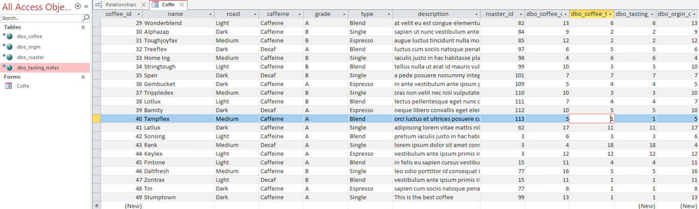

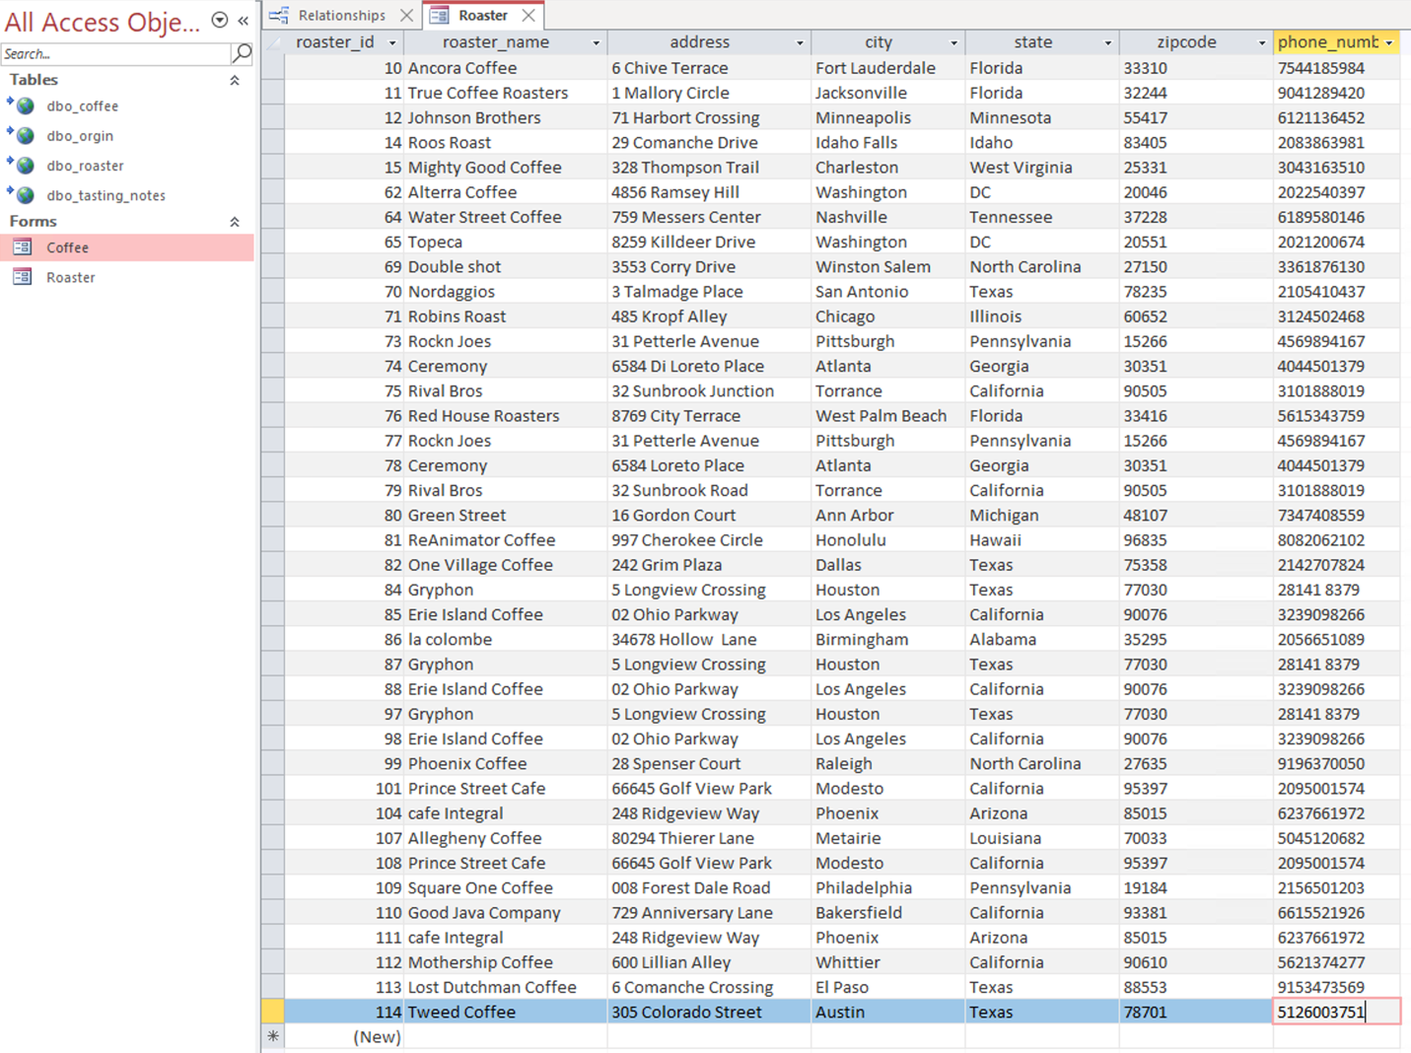

I choose to use Tableau to represent the visualizations because I am more comfortable with using Tableau to show data than other tools. I wanted to show the roasters and origin of the coffee on a map, in two different formats because I am a very visual learner and if this was my business it would help me understand very quickly my geographical data.

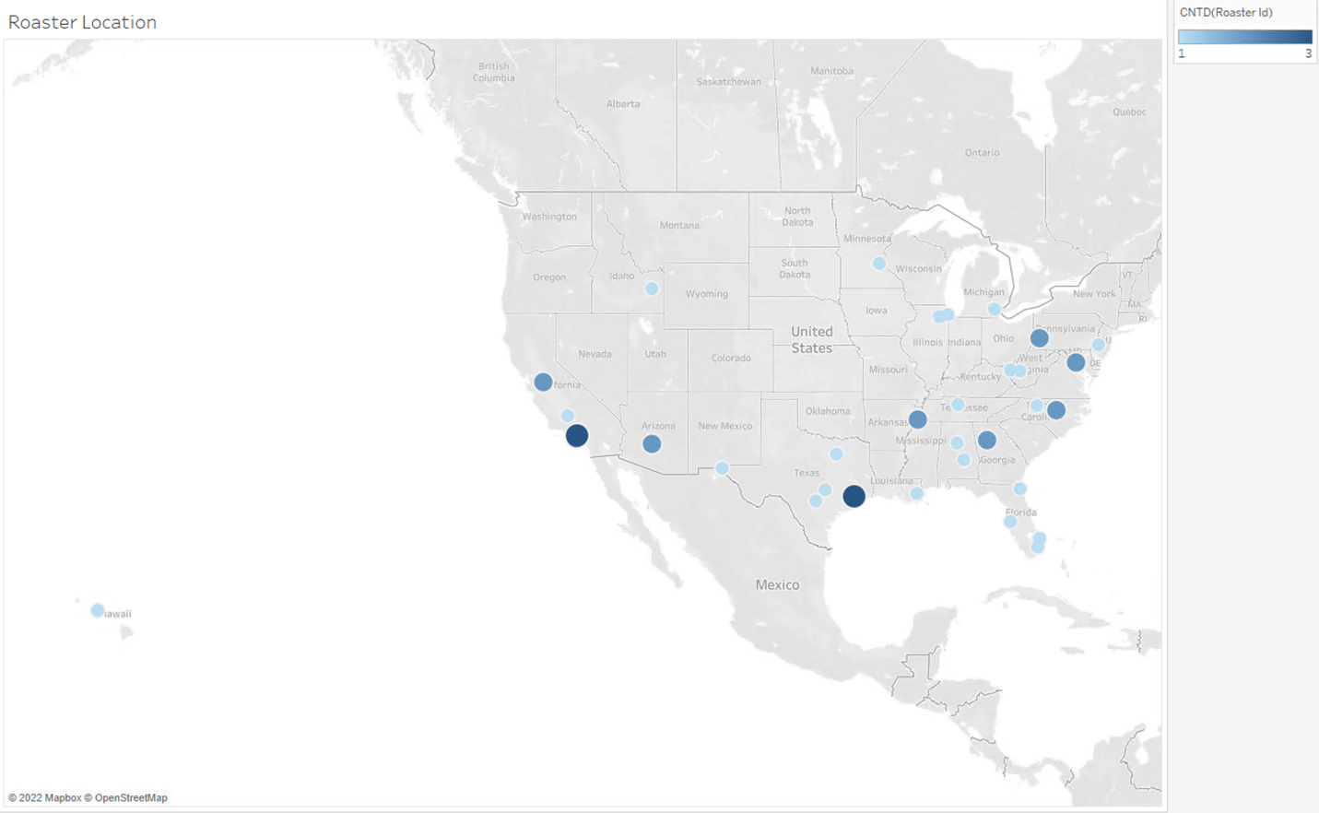

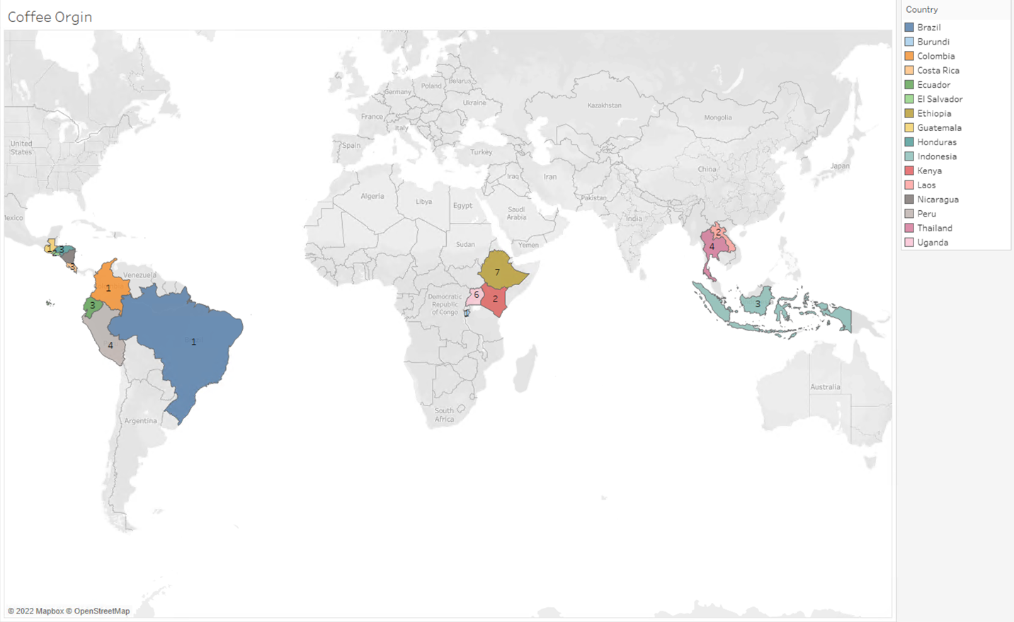

Reflection:

This was my first time designing a database from scratch. I tried to pick something I’m very interested in, which is coffee, and turn it into a business model. I think there would be a few things I would have done differently. First, I would have spent more time thinking about the business and what would be necessary to run the business and make life easier for end users. I probably should have also started off on a smaller scale in regards to designing the tables. I also noticed that I had a few ID fields repeated in different tables which could have been avoided. Overall, being able to create a map on the data I added into the database was really cool, but to be more effective it would have made more sense to report on customer data.